**My Career Goals**

 Complete 12 week training alongside Functional Skills

Take on entry level job or an apprenticeship

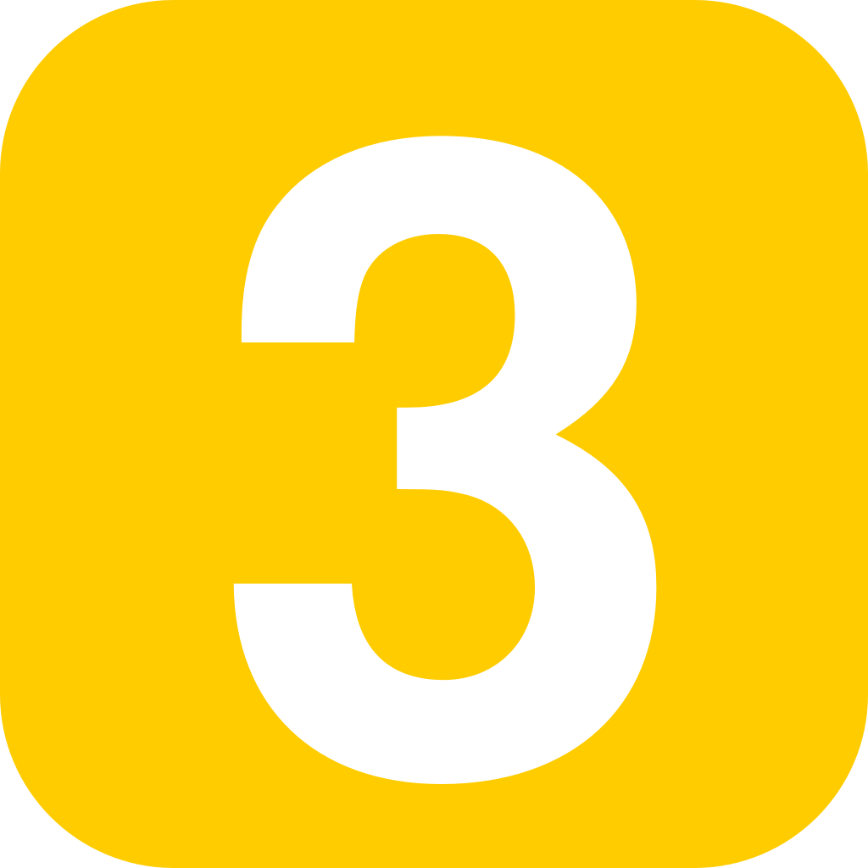 Take on a speciality, go into more training for said speciality (speciality undecided as of yet)

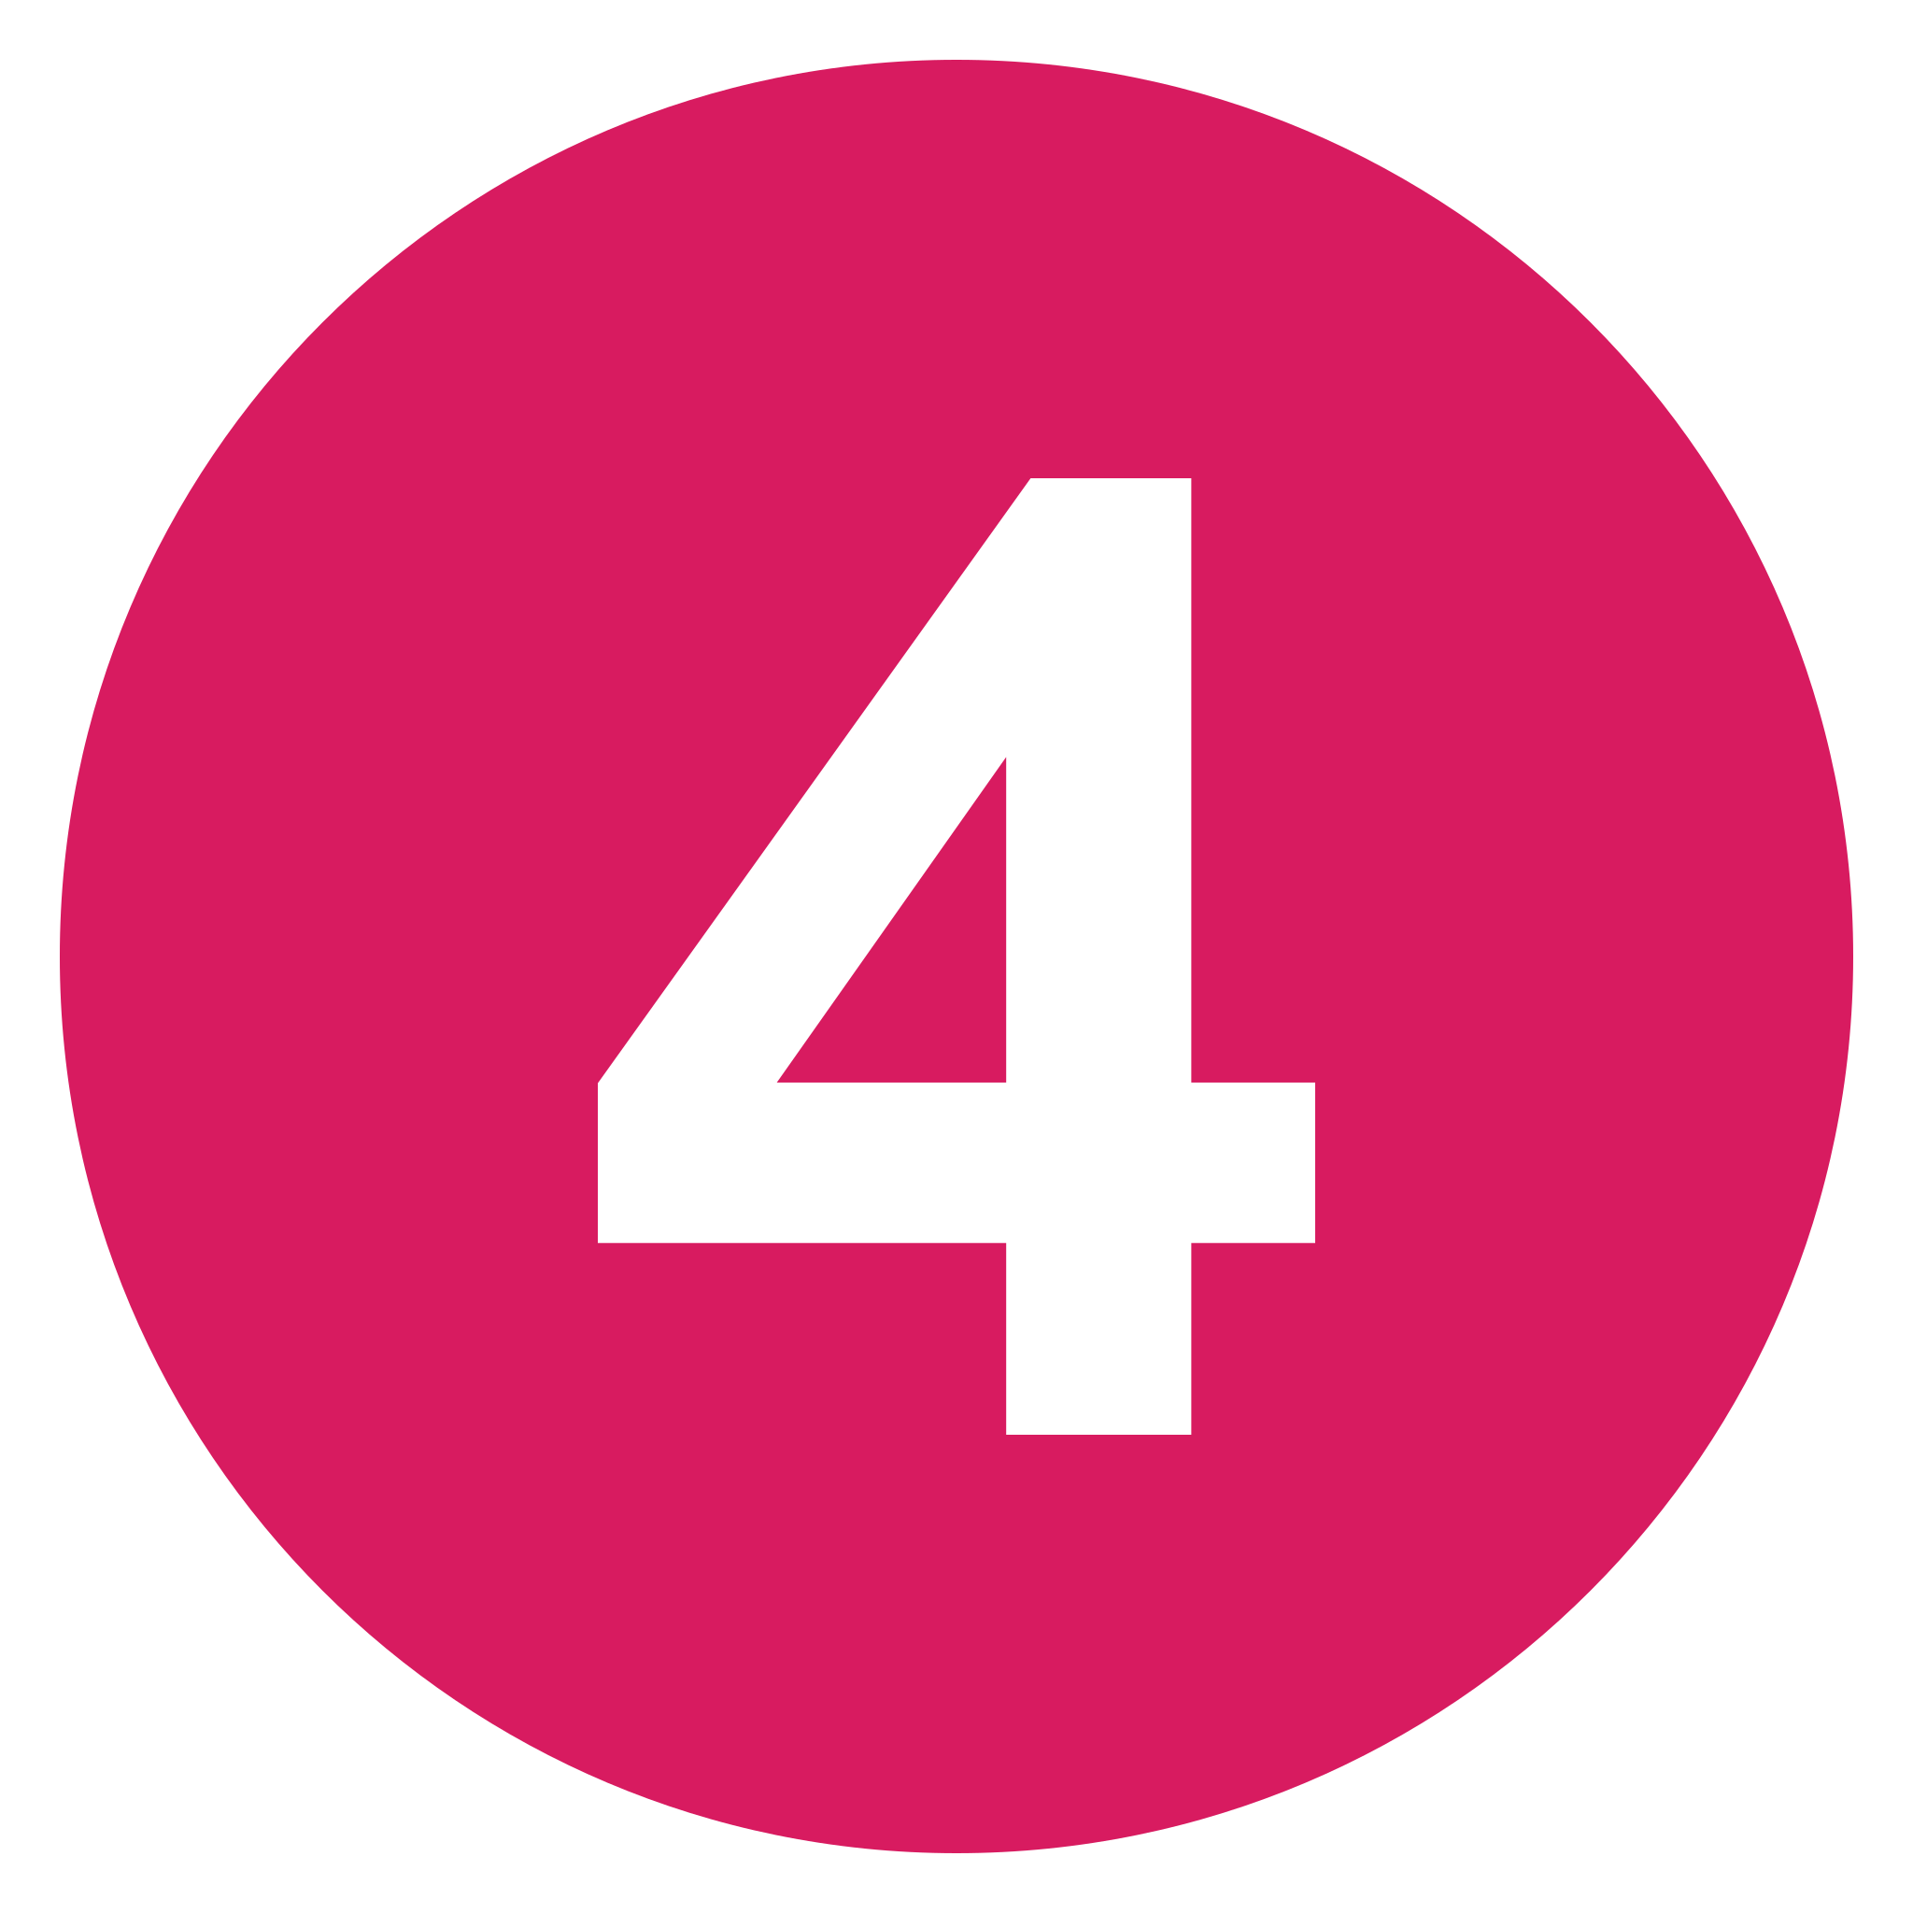Move on from lower level job into work doing my chosen speciality

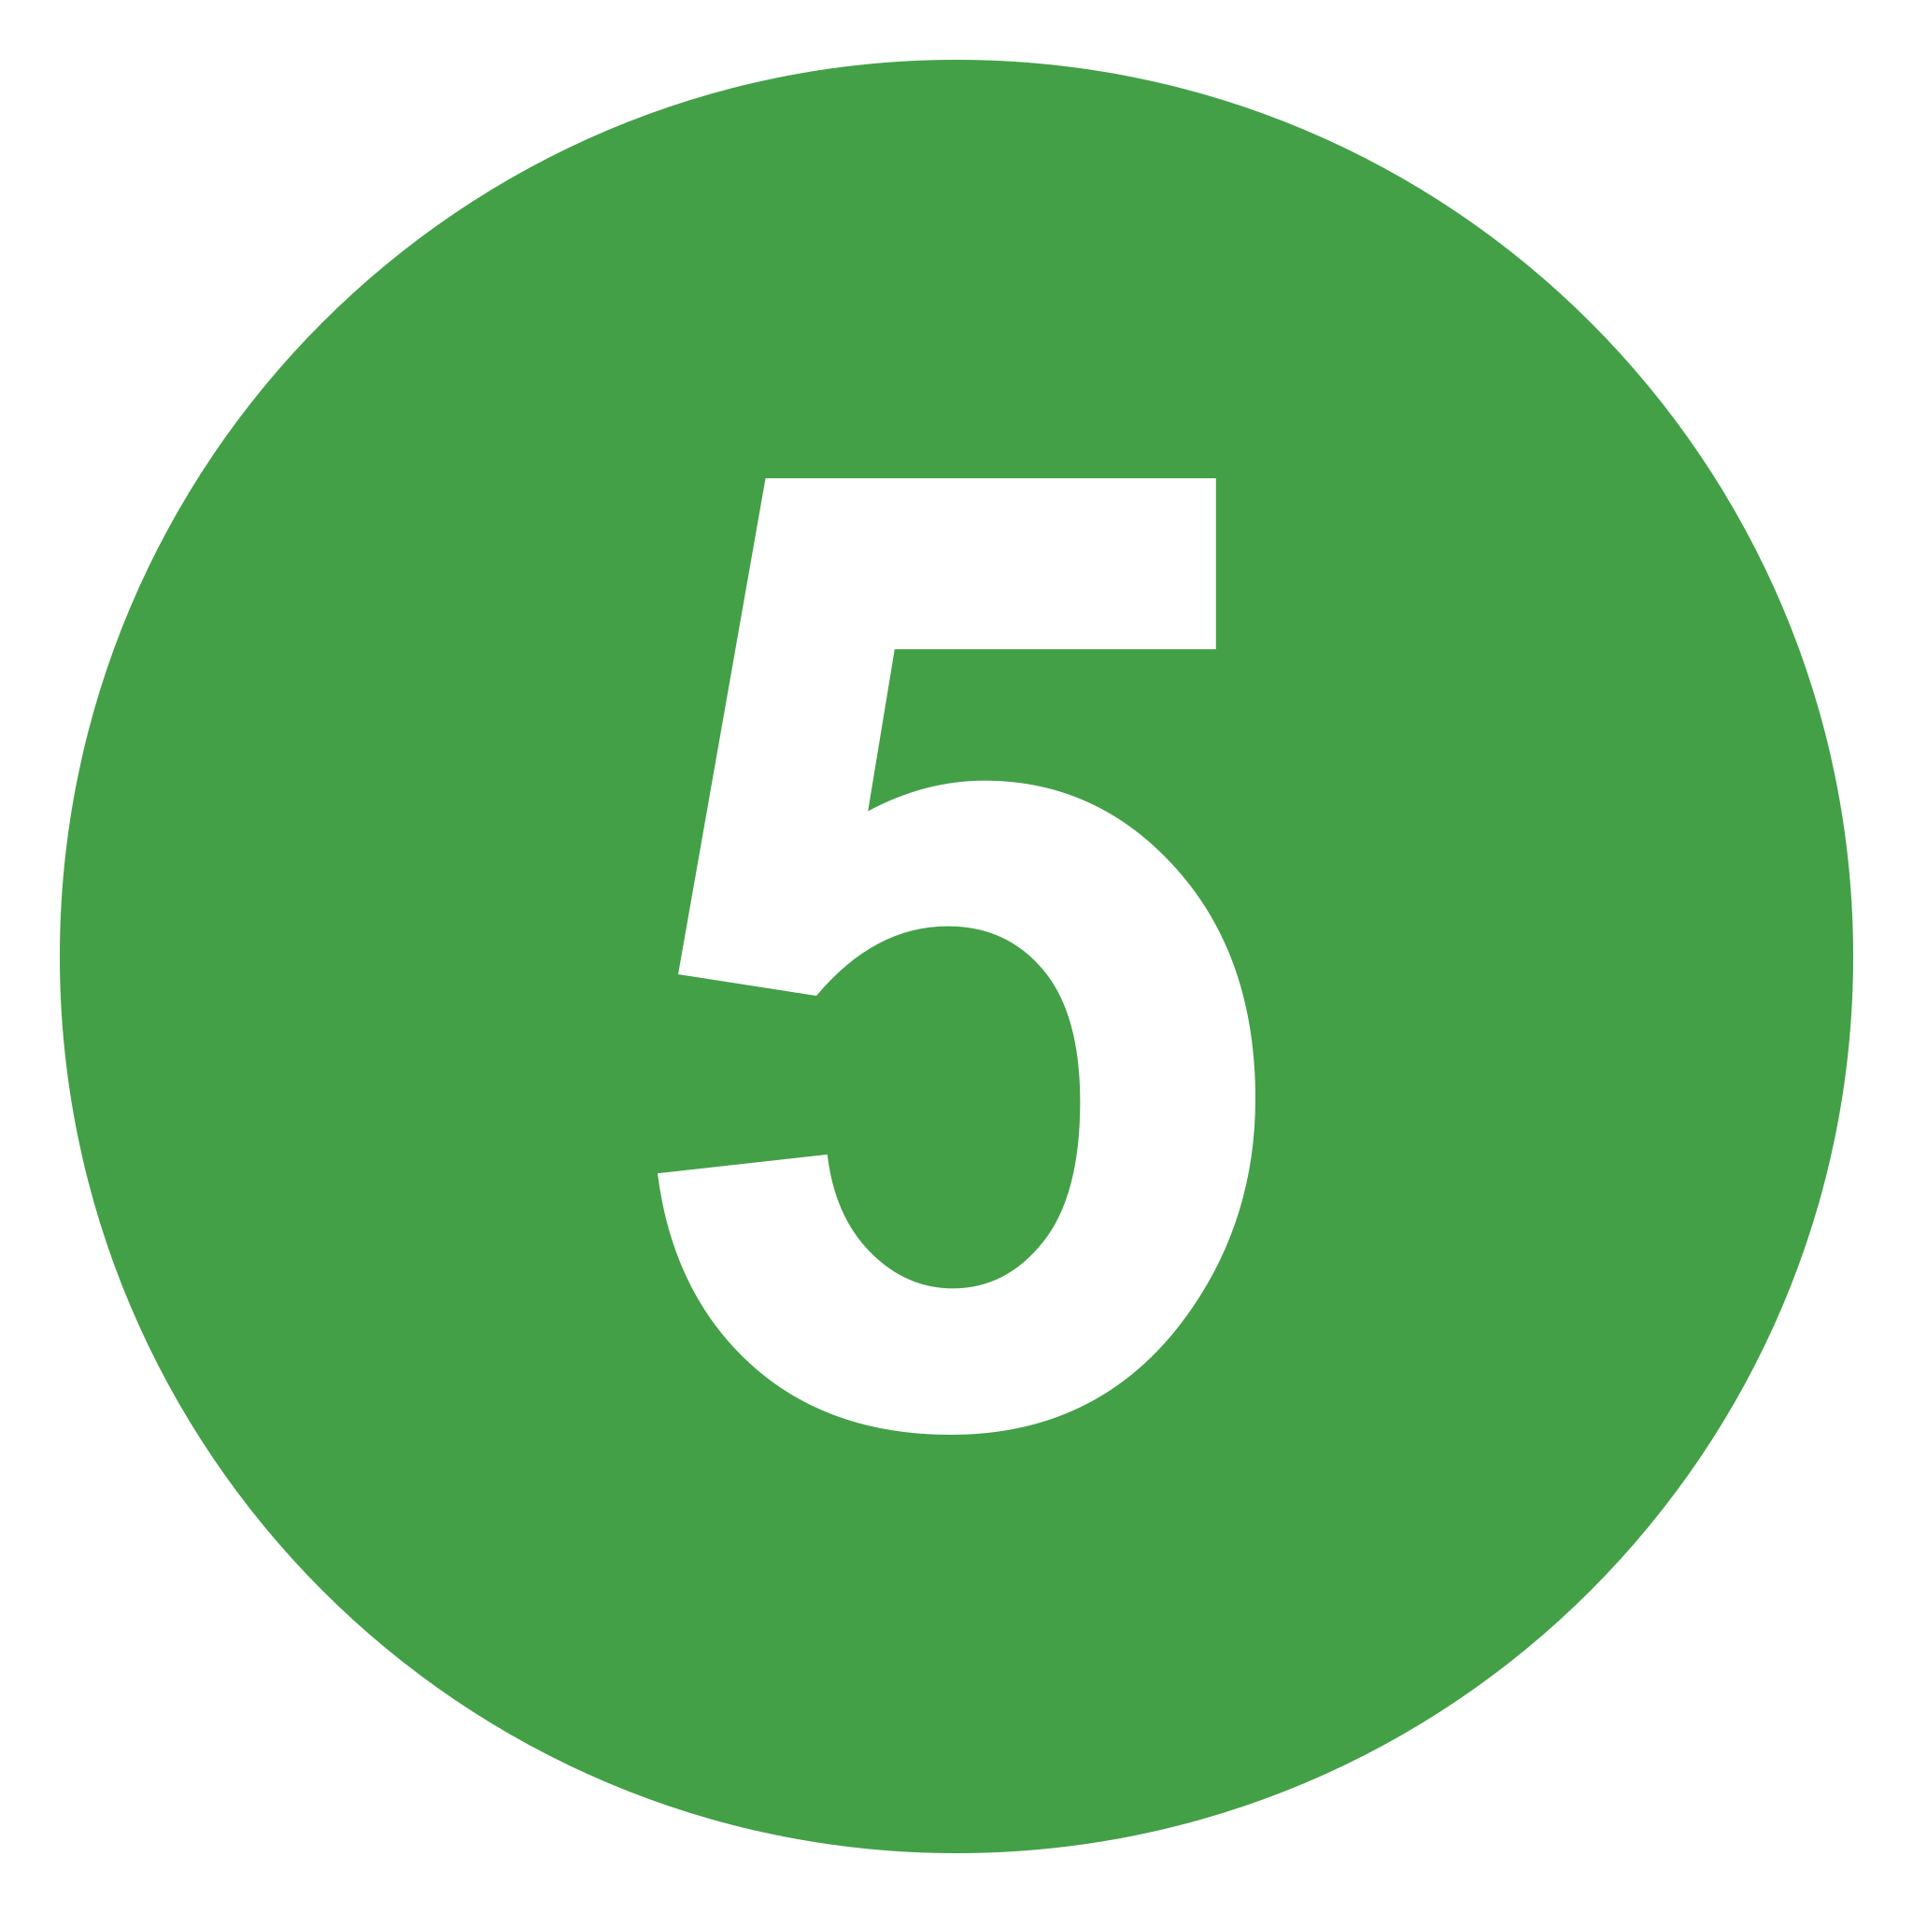Become a senior (developer/engineer etc)